How to Create & Implement
a Workers’ Comp Cost Allocation System

Introduction: (5 minutes – 2:05 pm)
- Welcome to WC Mastery training
  - It’s not a question of HOW to manage WC
  - It’s about MOTIVATION and ENGAGEMENT in best practices
- Introduce 3 Major Points
  - Drivers of Behavior
  - Cost Allocation Systems & Examples
  - Steps to Implement Cost Allocation

Main Point #1: Drivers of Behavior
- Cost Allocation is Simply Motivating Behavior
- Research Study: MIT “Large Stakes & Big Mistakes”:
  - Premise: A group of students was given a set of challenges:
    - Memorize digits
    - Word puzzles
    - Shooting a ball through a hoop
- Rewards: The cash rewards for performance were broken into three categories.
  - Small
  - Medium
  - Large
- Results:
  - mechanical skill only - rewards system worked as designed
  - Even rudimentary cognitive skill required: Opposite result
- Study has been replicated many times
  - Pre-schoolers who like to draw

- Rosabeth Moss Kanter: Hierarchy of Motivation at Work
  - "The key to motivation doesn't depend on elaborate incentive schemes. What makes a good work environment is getting better at stuff, or mastering a task."
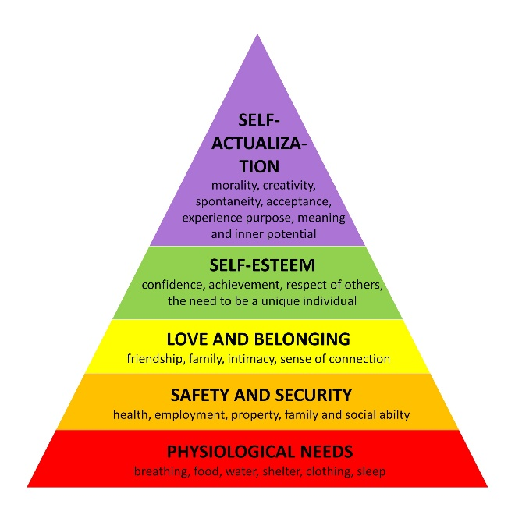

MEANING

MONEY
MASTERY
MEMBERSHIP

- Cost Allocation works because give divisions Autonomy to control workers’ comp costs and ability to Master
- Examples of Profit Sharing:
  - Charles Schwab
    - “To no small extent the success of Bethlehem steel has been built up by our profit sharing system”
    - “…unique leadership hierarchy that afforded lower managers much independence and greater pay”
  - 80% of 22,000 men on profit sharing system
    - Bonuses computed on efficiencies;
    - Examples:
      - Mechanic: allotted time for work is 20 hours, if finishing w/in 20 hours gets 20% bonus, if finishes in 12 hours gets full pay and 20% bonus.
        - Free to work on other projects or go home
      - Armor Plates
        - Bonuses on quality of work rather than quantity
      - Other departments
        - Bonuses for efficiencies
        - “everything you save from this standard cost you will share”
  - Andrew Carnegie: First big American businessman to inaugurate profit-sharing
  - Good to Great:
    - 7 Factors in Good to Great Companies:
      - First Who, Then What:
      - “not a “genius with a thousand helpers” leadership model
Notes:

Main Point #2: Cost Allocation Systems & Examples
- 3 Golden Rules of Cost Allocation:
  - Keep it Simple
  - Quickly provide feedback
  - Incentivize the Right Behaviors
- How are Operations Managers Held Accountable?
  - Control return to work, reporting claims culture, supervisor engagement
  - Goal should be to affect day-day decisions
  - Typically Profitability

- Typical Cost Allocation
 | 1 | 2 | 3 | 4 | 5
Claim Costs | 350k | 200k | 200k | 200k | 50k
Allocated | 200k | 200k | 200k | 200k | 200k
Profits | $1.050m | $1m | $1m | $1m | $900k
Adjusted | $900k |  |  |  | $1.050m

No accountability at the level of control
No motivation to return an injured employee to light duty

- Full Cost Method
  - Claims valued as of specified date at close of period
  - Budget based on 5 year-average
  - Make end-of-year adjustment based on actual performance

 | 1 | 2 | 3 | 4 | 5
Budget | 40% | 35% | 10% | 10% | 5%
Budgeted Claim Costs | 400k | 350k | 100k | 100k | 50k
Actual
Adjustment

Training required on best practices to follow

- Full Cost w/ Free Labor Method
  - If return employee to work, free labor for division
  - If do not return employee to work, indemnity charged to division
    - Free labor to maximum time limit & dollar amount
      - 10 weeks or $25k

- Lost-Time Method
  - Each department is allocated WC costs based on number of lost workdays
  - Two options:
    - Cost per day
    - % of total
 | 1 | 2 | 3 | 4 | 5
% of Lost Work Days | 35% | 20% | 20% | 20% | 5%
Total Days | 350 | 20 | 20 | 20 | 5
Cost per Day | $1000 | $1000 | $1000 | $1000 | $1000

- Flat Charge Per Claim Method
  - $25k charged per claim;
  - Not reported w/in 24 hours $5k extra charge
    - Unintended consequence?
    - NCCI - $1,500 / day cost
  - If bring back on light duty w/in 4 days - 50% discount
  - Free labor on light duty
    - Unintended consequence?
  - Bonuses based on claims frequency
- Promoting:
  - Prevention
  - Reporting
  - Return to Work

- Total Incurred w/ Refunds Per Claim Method
  - Take the total incurred each month
  - Reporting w/in 24 hours = 20% refund
  - RTW w/in 4 days = 30% refund
  - Calculate 1 - 2 - 3 to get the total charge for the claim for the month, and subtract from any other previous charges

 | May | June | July
Total Incurred | 10,000 | 7,500 | 7,000
Reporting Refund | (2,000) | (1,500) | (1,400)
RTW Refund | (3,000) | (2,250) | (2,100)
Claim Cost to Unit | 5,000 | 3,750  (1,250 credit this month) | 3,500 (250 credit this month)

- Monthly reporting on Status:
  - “if all conditions were met, you would have saved an additional $4,000”
- Need system to track RTW Dates & Injury Reporting
  - Coordinate with TPA/Carrier

- Notes
  - Where cap impact of one claim?
    - At retention level
  - How handle light-duty compensation?
    - Free Labor
  - Simple reporting options
    - Coding of payroll, accounting, etc.
  - Worst to Best List

Main Point #3: Steps to Implement Cost Allocation
- Implementation Tips
  - Evaluate what want to motivate
  - Develop method around goals
  - Once determine method, critically analyze what will actually motivate
    - Unintended consequences
  - Monitor and adjust
- Drive adoption with Success
  - Kroger: Jim Herring, CEO
    - How do you make over 50,000 people, cashiers, baggers, etc embrace change? You don’t, not in one big event anyway; “we presented what we were doing in a way that people saw our accomplishments…to gain confidence from the successes, not just the words”
- Pilot
  - Identify most liberal or proactive manager for Pilot of new program
  - Need senior management support, CEO, CFO

Notes:

