How to Determine Which
Insurance Structure Is Right For You

Introduction: (5 minutes)
- Welcome to WC Mastery training
  - Insurance Structure is fundamental platform to maximize ROI of injury management best practices
- Introduce 3 Major Points
  - Spectrum of Risk Financing
  - Choosing the Right Option for You (or your client)
  - Practical Steps to Get Started

Main Point #1: Spectrum of Risk Financing – (25-30 minutes)
- 4 Cornerstones of Insurance Structures:
  - Risk Tolerance
    - Degree of variability willing to withstand
  - Risk Predictability
    - Law of large numbers
    - Taking on risk by removing risk
    - Acceptable predictability can be accomplished through different structures and programs
  - WC Management Best Practices
    - How well employer preventing & managing injuries
    - Poor WC Management can’t be saved by insurance structure
    - Need to commit to preventing & managing losses
  - Financial Impact
    - Increasing retentions/deductibles allow for greater financial reward (getting access to carrier profits) but increase potential cost (if losses are greater than expected)
- Economics of Transferring Risk
  - 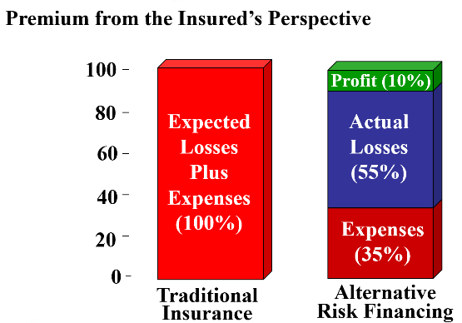
  - 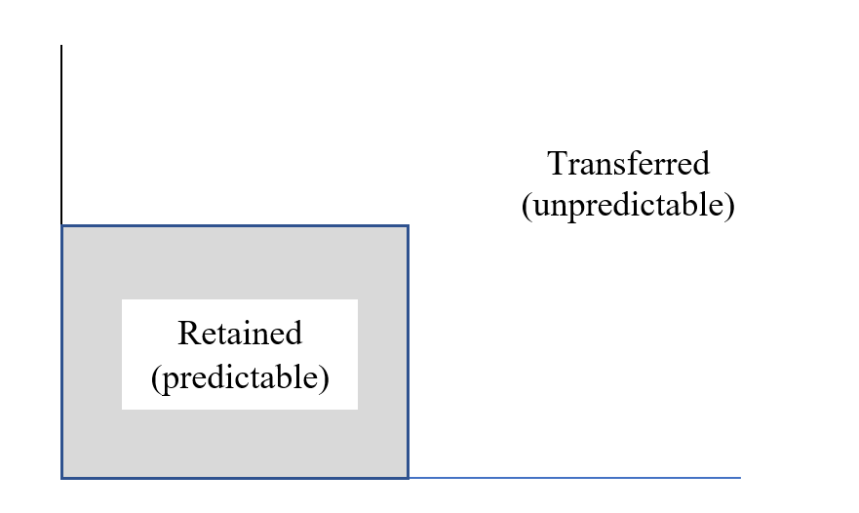
  - Frequency on horizonal access; Severity on Vertical access
    - Per claim on severity side, aggragate on frequency
  - Transfer of Risk
    - Where are your losses predictable? Capping losses at various retentions can help with that assessment.
      - Single claim cap, never had a big loss, going to take a $500k deductible; want profit margin on all losses on everything over $100k; single $500k claim is going to swing volatility. Can use historical experience to figure out based on retention what layer is predictiable; what is tolerable from a volitiltiy standpoint based on capping mechanism.
    - If your losses are not predictable on a stand alone basis, can you aggregate your losses with other companies with similar attributes to get critical mass to create predictable losses?
- Spectrum of Risk Financing
  - Definition of Insurance is ‘transfer of risk’
    - Risk / Reward / Control
  - Need to be Familiar with Various Options When Making Decision
    - Don’t be a one-trick pony
  - Guaranteed Cost
    - Dividend
  - Retrospective Rating
  - Deductible
    - Small
    - Intermediate
    - Large
  - Captives
    - Group
    - Rent-a-Captive
    - Single Parent
  - Self-Insured
- RIMS Benchmark Survey
  - Guaranteed Cost
    - 82% of companies < $100m in revenue
    - 18% choosing some deductible up to $250,000
    - 23% of total companies
  - $100,000 - $500,000 Deductible
    - 37% of total companies
    - Bell curve of deductible amount
      - $1,000 - $5m+
Guaranteed Cost
- Most common insurance structure in smaller companies
- Fixed Premium charged Prospective (before policy period)
  - Not changed by loss experience during period
  - Experience Mod
  - Risk Profile for carrier credits
- Easy to budget insurance costs
- Should be used as Benchmark for small to medium size companies
- Premium Includes:
  - Expected Losses
  - Buffer for Expected Losses
  - Expenses
  - Insurance Company Profit
- Dividend Program
  - Based on performance can receive return dividend (10%-20%)
  - Ask premium with and without a dividend
- Payroll x Rate x Exp Mod x Adjustments = Premium
  - Exp. $500,000 premium

Retrospective Rating
- Retrospective Rating
  - Starts similar to guaranteed cost with premium payment except:
    - Final premium retrospectively determined based on losses
    - No premium size discount
  - Minimum & Maximum Premium
  - Incurred vs Paid
    - Paid – better cash flow, collateral requirements
- Exp. $500,000
  - Standard Premium: $550,000
  - Basic Premium Factor (minimum): .40
    - Includes expenses & ins co profit
  - Maximum Premium Factor: 1.25
  - Loss Conversion Factor (ins comp buffer): 1.10
  - Tax Multiplier: 1.05

Maximum: $687,500
Standard: $550,000
Minimum: $231,000 (basic x tax multiplier)

6 Months Post Policy Reconciliation
Paid & Reserved Losses = $150,000
[Basic Premium ($220k) + Converted Losses ($165k)] x Tax Multiplier (1.05) = Premium ($404,250)
Returned Premium = $550,000 - $404,250 = $145,750

Deductibles:
- First dollar responsibility per claim shifts to Employer up to deductible amount (carrier pays first dollar & employer reimburses)
  - Per claim: $1k, $5k, $25k, $50k, $100k, $250k, $500k, $1m, $5m, $10m
  - Aggregate (optional) – 125 to 500% of actuarial expected losses within the deductible
    - Exp. $250,000 per claim, $1.5m aggregate
  - Carrier evaluates based on Underwriting & Credit Risk
    - Need for Collateral
- Payment Structure:
  - Premium + Claim Costs + Expenses + Surcharges = Total Cost
  - Premium:
    - 60% or 70% discount off standard
    - Lots of flexibility and carrier discretion
    - Could Use Single Rate
  - Expenses become Unbundled:
    - Unallocated & Allocated
    - Unallocated = carrier / TPA fixed expenses
      - Overhead, Phones, lights, rent, salaries, etc.
      - Per claim fee example:
        - $300 / medical only
        - $1,500 / lost time
    - Allocated = costs per individual claim
      - NCM
      - Surveillance
      - Peer Review
      - Bill Review
      - Medicare Set-Aside
      - Attorneys Etc.
- Much potential for employer control & broker service, often underutilized by both parties
  - Premium ($150,000) + Claim Cost ($100,000) + Expenses ($50,000) + Surcharges ($10,000) = $310,000

Captives
- Separate legal entity created as an insurance company. Owned and operated by members for the benefit of the members.
  - Company asset on balance sheet to manage risk.
  - Full control over decision making and management of company.
  - Participate in underwriting and investment profit
    - Startup Costs
    - Capital Requirements
- Example:
  - Acme company paying premiums to Travelers for High Deductible plan VS
  - Acme company paying premiums to Acme Captive Ins. Company.
    - Purchase guaranteed cost policy
    - Act as re-insurer for claims under the per-claim and aggregate limit.
- Different Captive Designs
    - Group
    - Rent-a-Captive
    - Single Parent

Self-Insurance
- Self-Insure up to Retention level, purchase excess policy
- Must file and receive approval from state insurance department
  - Regulatory burden
- Claims handled through TPA or Self-Administered
- Lowest cost structure & possibility for lowest-risk

Main Point #2: Choosing the Right Option for You (or your client) (30-35 mins)
- Decision Tree to determine of needs assessment and how going to make a decision;

- Once understand options, what are guideposts of decision making
  - Don’t be a one-trick pony
- Measuring Risk Tolerance:
  - Assess options & cost of transferring risk
    - What is cost of transferring everything?
    - What is cost and opportunity of retaining?
    - What are best- and worst-case scenarios?
    - How confident are you in projections?
    - Can you mitigate the cost of worst-case by sharing risk/reward with others?
    - Have you made RM improvements not accounted for by Underwriters?
    - Do you want access to profit margin and ability to control expenses?
- Considerations:
  - Risk tolerance
  - Financial stability
  - Projected Cash Flow
  - Income Statement
  - Balance Sheet
  - Tax Implications
  - Access to Investment Income
  - Does the structure/carrier/group give you access to claims, loss control or best practice resources?
  - Amount and Type of Losses
    - Placing risk in wrong structure too early can have disastrous effects
    - Good outcomes lower costs, bad outcomes increase costs
  - Attached needs directly to the insurance structures
    - Bundled / unbundled conversation; claims, how much control?
    - Financing retained losses with cash or Letter of Credit?
    - Tolerance relative to guaranteed cost in knowing your total cost of risk;
    - How strongly do you feel about sharing risk with others?
    - Flexibility in Structure
      - What are your goals?
      - As move up retained risk have a lot of flexity in terms of how to handle and plan expenses, structures, and how fund structures; captives give you a lot of flexibity in those areas.
- Use of an Actuary
  - Credibility of loss projections
  - Experience Mod Worksheet – Weighting Value
- Engage in Conversation & Educate
  - Share pros and cons of each option
  - Run what if scenarios
  - Opportunity to improve WC management in Loss Sensitive plans

Guiderails Based on Standard Premium
- $0 - $300,000: Guaranteed Cost/Small Deductible
- Association Group Program/Self-Insured Group – pay guaranteed cost. Risk/reward based on only group’s performance
- $100k - $1.5m - Retro
- $200k - $1.5k – Group Captive
- $750k+ – Rent-a-Captive Captive
- $750k+ - Large deductible
- $2m+ - Single Parent Captive
- $500k+ - Self Insurance (subject to state rules of minimums)

Guaranteed Cost
- Most common insurance structure in smaller companies
- Fallback consideration and baseline for decision making

Retrospective Rating
- Most common structure which is incorrectly chosen
  - Lower initial cost, better cash flow seen as attractive
  - Poor WC Management leads to surprise costs
    - exp. Washington Mutual Option ARMs in housing boom
- Readily available options in marketplace
- Consideration:
  - Ensure stakeholders familiar with elements of plan (no surprises)
  - Some flexible and customizable
    - Upper middle market may be more flexibe to be in large deductibe. Vs retro
  - Incurred vs Paid
    - Collateral requirements
    - Cash Flow
  - Lack of control over claim handling and potentially how it is priced
  - Understand all elements of retro contract
- Review Guaranteed Cost Pricing
  - What loss amount would be lower/higher than GC
  - Decide based on odds to beat this number

Deductibles:
- Considerations:
  - Unbundled Claims Handling Expenses – Allocated vs Unallocated
    - Options for insurance carrier and TPA to be separate entities
    - Better control of fee arrangement for Allocated Expenses
  - Deductible & Premium Options
    - Choose specific retention based on predictable losses, the cost to transfer risk, and risk tolerance
    - Choose Aggregate limit or Not
    - Leverage Independent Actuary
  - Collateral requirements can be significant and build each year
    - Understanding multi-year collateral obligations can be tricky
    - Leverage Independent Actuary
  - Financial stability of employer
    - Cash flow
    - Collateral requirements
    - Income Statement / Balance Sheet
  - Financial stability of carrier
    - Are collateral requirements too low?
  - WC Management systems and management commitment
  - Partnership with claims handler
  - Regulatory burden on insurance carrier
  - Lots of flexibility in plan design
Captives
- Employer will own and operate an insurance company
  - Additional time requirement and resources for decision making
  - Regulatory requirements
- Broader Coverage/Flexibility to add coverage
  - Availability of coverage in commercial insurance market
  - Price of coverage in commercial insurance market
- Increased Control
- Collateral requirements
  - Capital requirements
- Financial Stability
  - Proforma Cash Flow/Profits
  - Tax impact
- Domicile
- If Group: how are members determined, does size of group create leverage on cost, how is risk shared
- Engage Actuary - Captive Feasibility Study
  - Control
    - Risk management control
  - Cost
    - Short term
    - Long-term
    - Tax implications
  - Capacity
    - How captive builds retention capacity

Main Point #3: Practical Steps to Get Started (5-7 mins)
- The decision for the right insurance structure is not made alone!
  - Not a short process not about markets, its about needs;
- Further Educate Yourself:
  - Talk with more experienced brokers & advisors
  - Ask questions to confirm or add perspective to what’s been discussed
- When making decision bring in stakeholders to discuss options:
  - Employer
  - Broker
  - Risk Advisor
  - Accountant
  - Attorney
  - Actuary

